**Cognizant Digital Nurture 4.0**

***WEEK-2 Module 4 JUnit Basic and Advanced Testing***

**Exercise 1: Setting Up JUnit (Mandatory)**

**Scenario:**

You need to set up JUnit in your Java project to start writing unit tests.

**Steps:**

1. Create a new Java project in your IDE (e.g., IntelliJ IDEA, Eclipse).

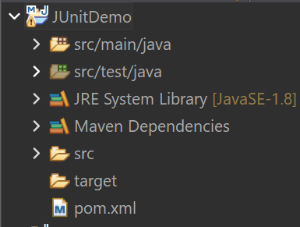

2. Add JUnit dependency to your project. If you are using Maven, add the following to your

pom.xml:

<dependency>

<groupId>junit</groupId>

<artifactId>junit</artifactId>

<version>4.13.2</version>

<scope>test</scope>

</dependency>

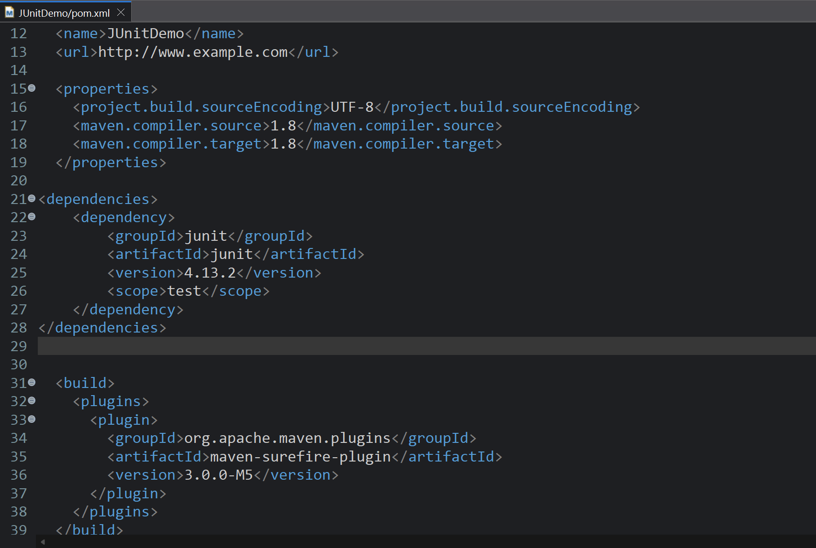

3. Create a new test class in your project.

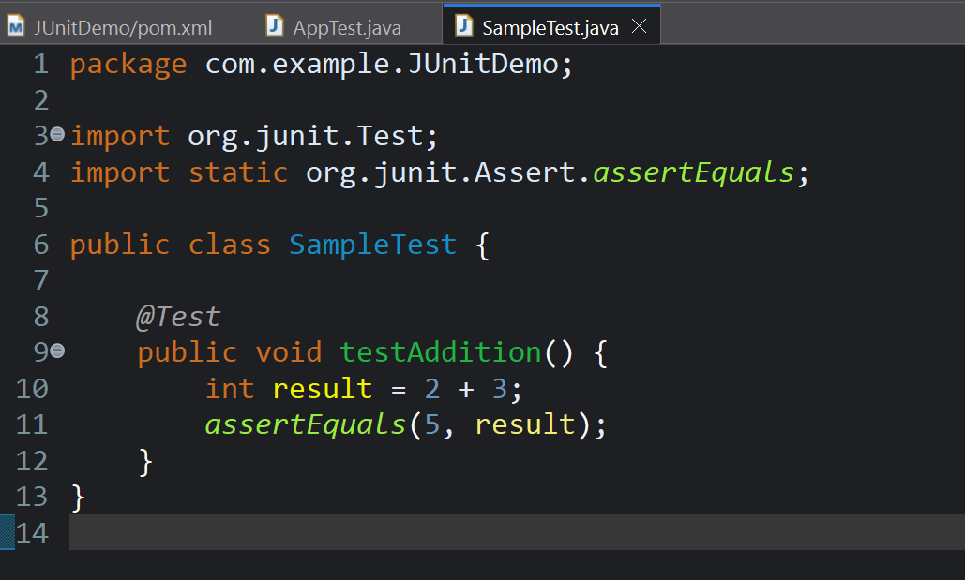

Output:

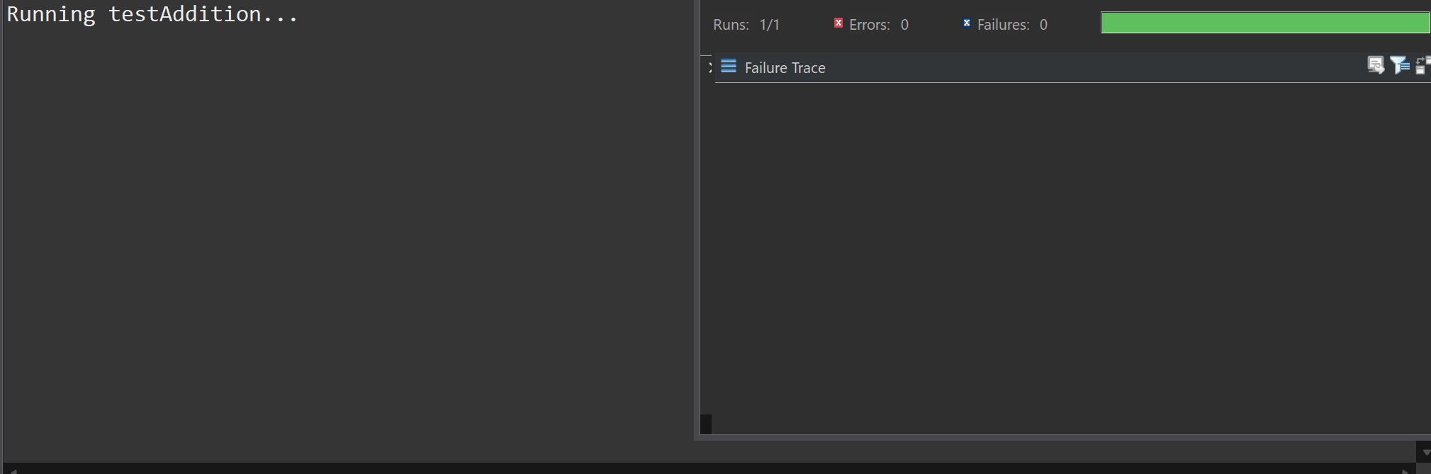

It successfully runs.

**Exercise 2:** **(Non - Mandatory)**

Writing Basic JUnit Tests

**Scenario:**

You need to write basic JUnit tests for a simple Java class.

**Steps:**

1. Create a new Java class with some methods to test.

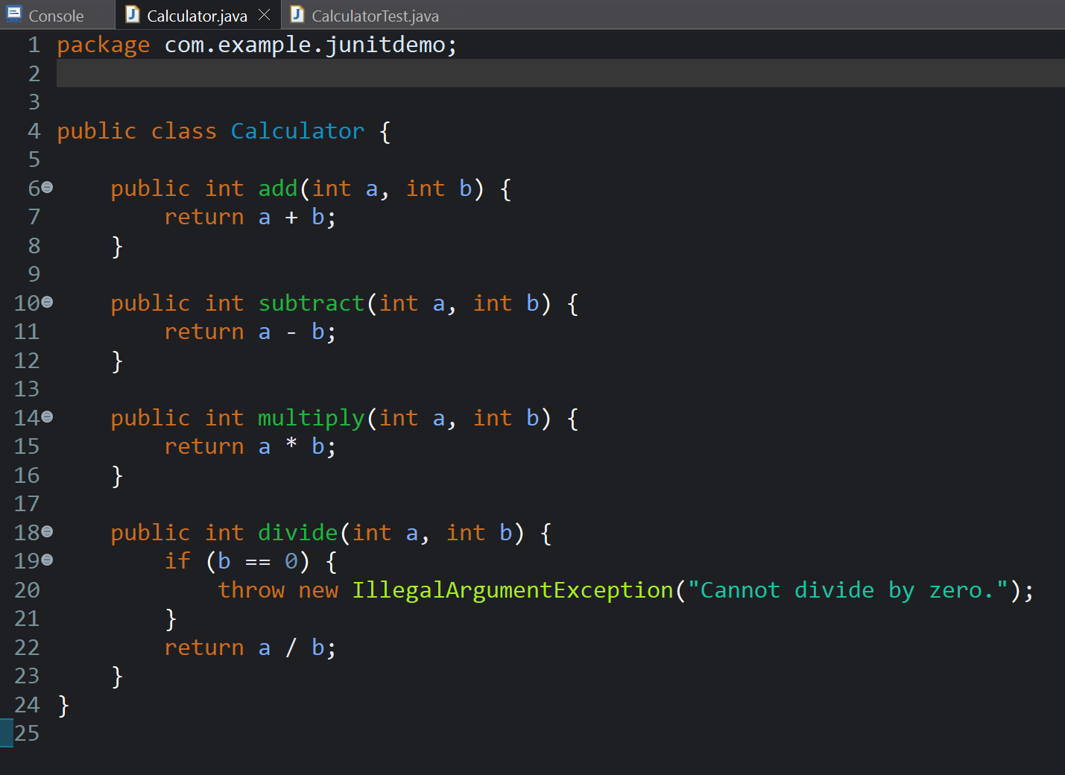

1. Write JUnit tests for these methods.

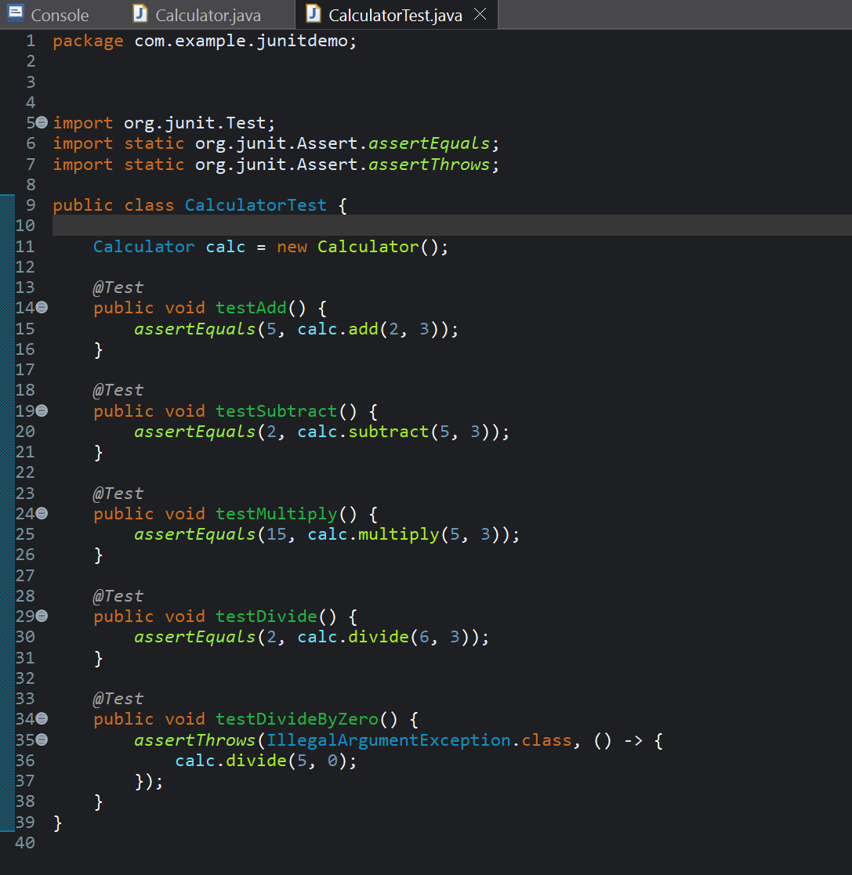

It successfully runs:

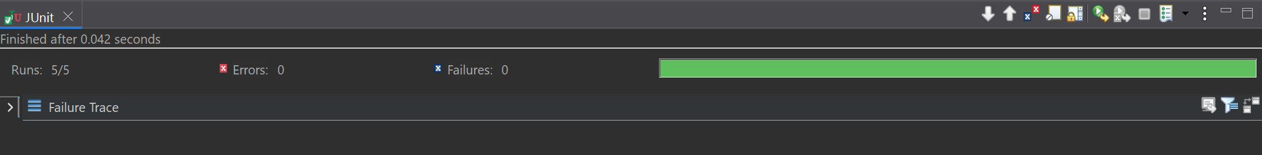

**Exercise 3: (Mandatory)**

Assertions in JUnit

**Scenario:**

You need to use different assertions in JUnit to validate your test results.

**Steps:**

1. Write tests using various JUnit assertions.

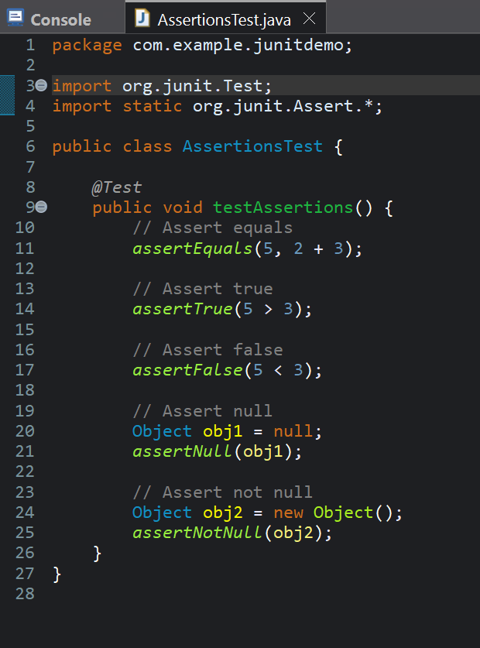



**Exercise 4: (Mandatory)**

Arrange-Act-Assert (AAA) Pattern, Test Fixtures, Setup and Teardown Methods in JUnit

**Scenario:**

You need to organize your tests using the Arrange-Act-Assert (AAA) pattern and use setup

and teardown methods.

**Steps:**

1. Write tests using the AAA pattern.

First creating a normal test class:

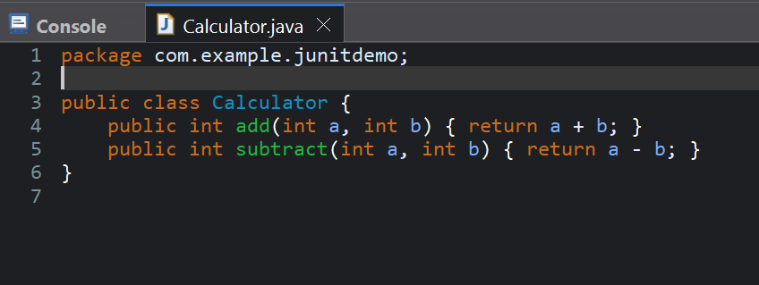

Then creating a Test Class Using AAA by using @Before and @After annotations for setup and teardown methods.

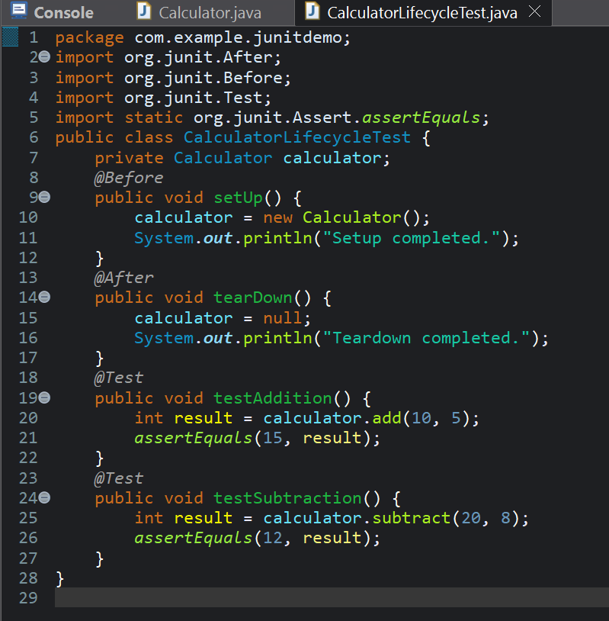

Output:

